**PROOF OF TEST**

**SIGN IN:**

VALIDATION:

Enter the URL in any window , Login Page should be displayed

EXPECTED RESULT:

Login page should be displayed successfully

SCREENSHOT:

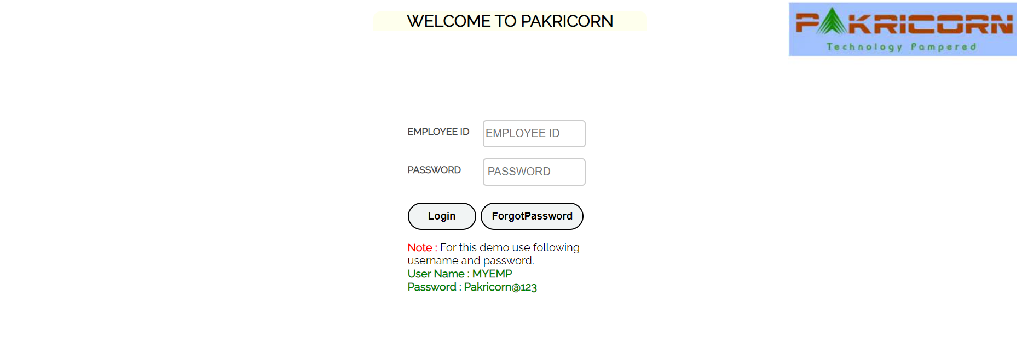

**WEB ELEMNTS OVER THE SCREEN:**

VALIDATION:

Verify that the login screen contains elements such as "Username"," Password", "Submit Button" "Forget Button"

EXPECTED RESULT:

All the web elements should be available on the screen successfully

SCREENSHOT:

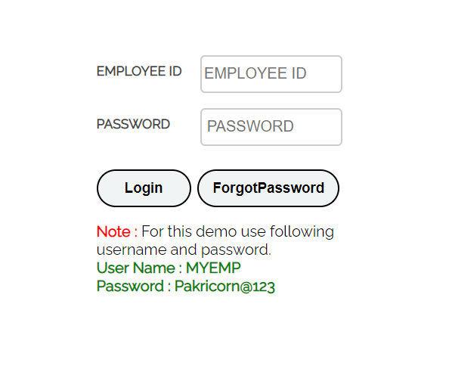

**HEADER:**

VALIDATION:

Verify the icons aligned with the text over the "header

EXPECTED RESULT:

Icons aligned with the text should be displayed successfully

SCREENSHOT:

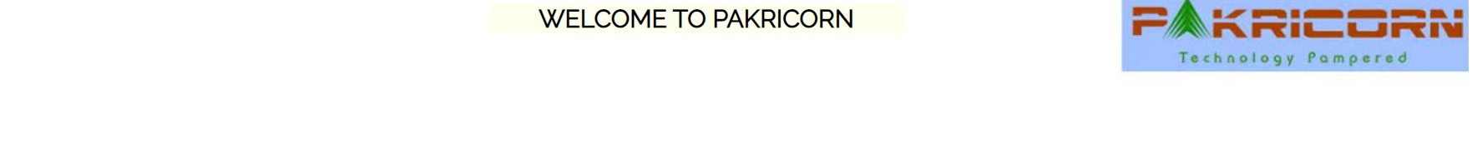

**EMP ID TEXT-BOX:**

VALIDATION:

Verify that all the fields such as "EMP ID" with the text box and should be clickable

EXPECTED RESULT:

Emp ID & Text Box should be clickable Sucessfully

SCREENSHOT:

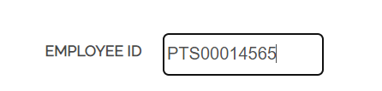

**PASSWORD TEXT-BOX:**

VALIDATION:

Verify that all the fields such as "PassWord" with the text box and should be clickable

EXPECTED RESULT:

Passowrd Text Box should be clickable successfully

SCREENSHOT:

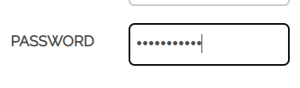

**LOG IN:**

VALIDATION:

Verify the "Submit button" along with the text in it should be available. it should be clickable and highlighted

EXPECTED RESULT:

The Submit Button should be aligned properly with the text and it should be clickable

SCREENSHOT:

Login Button Highlight



**FORGOT PASSWORD BUTTON:**

VALIDATION:

Verify the "Forget button" along with the text in it should be available it should be clickable and highlighted

EXPECTED RESULT:

Forget Button should be aligned properly with in the text and it should be clickable

SCREENSHOT:

Forget Button Highlight

